An Extensive Analysis on the different Time Series Algorithms and Understanding the Performance on the real time Data

*Abstract*

Demand Forecasting is a Time series Forecasting problem, which forecasts or predicts the future demand or sales of any given product. It is undeniably the most important component of any organizations Supply Chain. This helps in the checking the preparedness of the SCM for the estimated forecast given by the demand planners. It goes without saying that if an organization’s forecasting isn’t accurate to a reasonable level, the whole supply chain gets affected. Understandably, Over/Under forecasting has deteriorating impact on any organizations Supply Chain and thereby on the Profits and Losses. Having taking the effect the importance of Demand Forecasting, it is fair enough to discuss about the forecasting techniques which are used to predict the future forecasts of the data and the demand for a product. The input that goes in and the modelling engine which it goes through are equally important in generating the correct forecasts and determining the Forecast Accuracy. There are various advanced Statistical Time series methods for forecasting demand which are being used by Multi-national companies on a daily basis like xgBoost, combination of two or more techniques like Exponential smoothing and Auto Regressive models, and many more; but we focus here on the new and upcoming applications of machine learning and deep learning regression models on demand forecasting. Here, a very unique model to model exhaustive comparison of the state of the art Statistical, ML and Deep learning models used in forecasting demand is presented. The Data-set used is a real time dataset with association with Analytic Labs, Bangalore, India and consists of 5 products sales history ranging to 3 years of weekly data.

**Keywords**: Supply Chain, S&OP, Time Series Forecasting, Machine Learning, Deep Learning, Outliers Treatment

**Research Problem and Problem Statement**

How to forecast the upcoming time periods looking into the patterns and behaviour of the data in the past? How to incorporate all the irregular behaviour occurring in the history data and apply to the new unseen data, so that the accuracy is not hampered? How to follow the patterns in the past time period and how to retain the cyclicity of the data? The complete dataset consists of 5 different products and hence require different pre-processing steps and formulation of the algorithms to come up with a better forecasting accuracy.

**Value**

In any supply chain industry, demand forecasting plays a very vital role not only in bringing the profit but also maintaining the right quantity of products at the right time. It is one of the key driving factors in planning and decision making for any Supply Chain Management and Enterprise level. Supply chain management is the management of the flow of goods and services and includes all processes that transform raw materials into final products. It involves the active streamlining of a business’s supply-side activities to maximize customer value and gain a competitive advantage in the marketplace. The efficiency or accuracy of the demand forecasting is taking as the major account for taking any major decisions such as capacity building, resource allocation, expansion and forward or backward integration etc. Hence, the forecasting of demand is the first task which is carried out in the Supply chain management and its crucial to be accurate in order to maximize efficiency of planning and also to minimize costs. The various methods used for forecasting demand are discussed here, but first a brief description about forecasting itself and its importance in Supply chain management is looked upon. Forecasting is a prediction problem or an estimation of an actual value that happened in the past for the up-coming future time period. It is foreseen and understandable that there might be some forecast errors as the actual results might be differ from the projected/forecasted value, and for a longer time horizon the chance of having more error is evident. This is important to measure the forecast error and have a plan for adapting corrective action to correct the scenario. The development of advanced technology enables the Supply Chain Management stakeholders to share real time data and information across the network which helps dual benefit to inventory and customer service. This underlying result of the process is accuracy of forecast which firmly ensures the successful and sustainable business operations. This is called Collaborative Planning, Forecast, and Replenishment [1][9].

Sales and Operations Planning (SOP) is an integration process used in business organization to ensure efficient coordination among cross functional units to align company strategy with Supply Chain planning. Various forecasting models are used to predict what the demands on the system will be in the future so that appropriate designs and operating plans can be devised. Here we present some of the well-known models used widely for forecasting demand, and an extensive comparison of their performances are made and inferences are drawn [6][7].

**Impact of Research**

The various forecasting models that are examined can be categorized roughly into three different categories, which are, Statistical models, Machine Learning regression models and finally the newer Deep Learning models [5]. The chart based representation of these three categories can be seen in the below Figure.

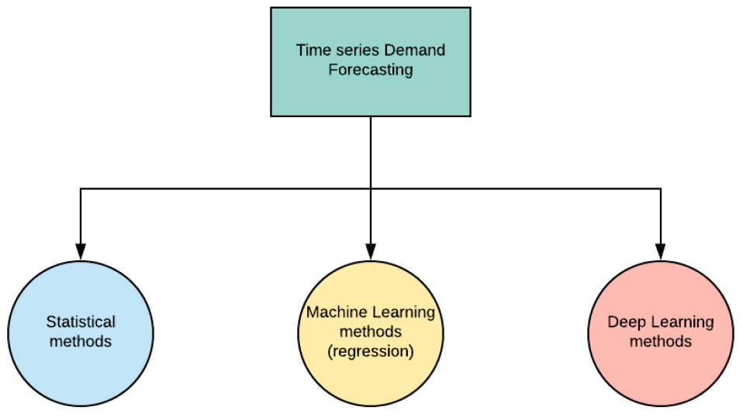

The models under Statistical methods are Auto Regressive (AR), Simple Moving Average (SMA), Auto Regressive Moving average (ARMA), Auto Regressive Integrating Moving average (ARIMA), Simple Exponential Smoothing (SES) and Holts-Winter Exponential Smoothing (HWES) model [ref 2]. Machine Learning (ML) models again can be classified into two categories, Linear and Non-Linear models. The Linear ML regression models used are Linear(lr), Lasso, Ridge, Elastic Net (en), Huber, Lasso Lars (llars) and Passive Aggressive (pa) regressor models. The Non-Linear ML regression models used are K-Neighbours, Decision Tree, Extra Tree, SVR, AdaBoost, Bagging, Random Forest, Extra Trees and Gradient Boosting regressor models. Finally, the Deep Learning models used are LSTMs and Multilayer Perceptron (MLP) [3].

**Justification of the Research**

Machine learning can be applied to time series datasets [1]. These are problems where a numeric or categorical value must be predicted, but the rows of data are ordered by time. In order to fit all the models discussed in the previous section, we needed to choose a good quality standard datasets on which to train and forecast [4]. Time series datasets that only have one variable are called univariate datasets. These datasets are a great place to get started because:

* They are so simple and easy to understand.
* You can plot them easily in excel or your favourite plotting tool.
* You can easily plot the predictions compared to the expected results.
* You can quickly try and evaluate a suite of traditional and newer methods.

One such univariate standard time series dataset used in many competitions is the Shampoo sales dataset. This dataset describes the monthly number of sales of shampoo over a 3-year period. The results that shows up in this standard dataset can be then further used for the real time dataset. The real time data set if for the top beverages company whose 5 top most sales history of the product will be used for the forecasting. The below is the pattern of the Shampoo dataset which is the standard public dataset.

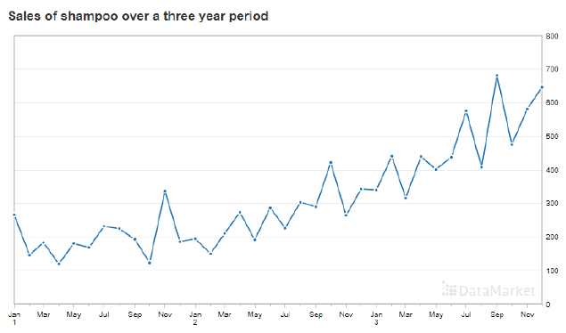

The model that we will be making will try to run across all the algorithms and find the best of rmse and fix that one. As different models are used, the best of the time series and machine learning will be ensembled and checked the rmse. In this, the accuracy can be improved as the over forecasting and under forecasting can be taken care of and the trade off of the results will try to nullify the error [9].

For finding out the forecast for the upcoming months, the whole of the data should be used to check for the pattern and to check for the stationarity of the data. The outliers can be treated using either mean-standard deviation or by MAD [9]. Since all of the data science life cycles are followed, this makes one of the most researched topic for the SCM industries and Machine Learning researchers. According to [1], not much of the research is done on the field of application for ML in the field of Time series forecasting for the *Sales-IN* data.

**References**

[1] N. C. D. Adhikari, N. Domakonda, and C. Chandan, “An intelligent approach to demand forecasting,” International Conference on Computer Networks and Communication Technologies, 2019.

[2] P. J. Brockwell, R. A. Davis, and M. V. Calder, Introduction to time series and forecasting. Springer, 2002, vol. 2.

[3] G. P. Zhang, “Time series forecasting using a hybrid arima and neural network model,” Neurocomputing, vol. 50, pp. 159–175, 2003.

[4] K.-j. Kim, “Financial time series forecasting using support vector machines,” Neurocomputing, vol. 55, no. 1-2, pp. 307–319, 2003.

[5] S. Ho, M. Xie, and T. Goh, “A comparative study of neural network and box Jenkins arima modelling in time series prediction,” Computers & Industrial Engineering, vol. 42, no. 2-4, pp. 371–375, 2002.

[6] N. K. Ahmed, A. F. Atiya, N. E. Gayar, and H. El-Shishiny, “An empirical comparison of machine learning models for time series forecasting,” Econometric Reviews, vol. 29, no. 5-6, pp. 594–621, 2010.

[7] A. Pankratz, Forecasting with univariate Box-Jenkins models: Concepts and cases. John Wiley & Sons, 2009, vol. 224.

[8] Z. Tang, C. De Almeida, and P. A. Fishwick, “Time series forecasting using neural networks vs. box-Jenkins methodology,” Simulation, vol. 57, no. 5, pp. 303–310, 1991.

[9] Adhikari, Nimai Chand Das, et al. "Ensemble methodology for demand forecasting." 2017 International Conference on Intelligent Sustainable Systems (ICISS). IEEE, 2017.